CHAPTER 1
INTRODUCTION

SQL Learning app is a form of application which allows consumers to directly learn the SQL over the Internet using to browser a Android mobiles. Users may ask for solution if occurred during learning process through Forum Module. It will also conduct Online Test which is MCQ based to know about their progress in learning.
The application will also consists of forum which will help them to post their doubts related to app. Others can reply on the particular doubt and depending on the help they will be rewarded. User will able to learn and perform structure query language on the application. Difficulty occurred while retrieving huge amount of data when query is executed like large response time.Difficulty in processing of data, so we are using SQLite database. Execution of query can be done in the application itself with its offline feature.
The users can inquire about their doubts on the forum. Some of the features are It should provide an interactive user interface for registration and log in. It should provide all the sql query definition along with syntax and examples. It should give desired results of user query. It should provide Forum to solve their doubts and users will be getting reward for helping other.
It should provide multiple choice based question to test their knowledge and understanding of the concept. It should provide multiple choice based question to test their knowledge and understanding of the concept.
Key SQL Statements like primary key, foreign key, unique key, etc. are used. Retrieving, Updating, and Filtering Data queries can be used in database server with same functionality. Functions and Subqueries are important aspect and it is widely used in terms of data retrieval.
Creating, Updating, and Deleting Tables are the data definition language and can be used in different database server. Joining Multiple Tables which enhanced query processing techniques, concept will be cleared.
I would be taking user input details in text format then sent to the cloud vision API for detecting the different tags and based on the highest probability of the tag, the details will be searched in the existing catalogue database.
For users who used be reviewing for the first time there will be registration form in which user has to fill all their details post which they will be allowed to set a username.On learning a SQL the user details will be used by the system to provide the intelligent recommendations to the users.

CHAPTER 2
LITERATURE SURVEY
VALENTIN PUPEZESCU PRESENTS “DATABASE REPLICATION IN THE EASY LEARNING ONLINE PLATFORM ”2015 The Easy Learning platform has now a back-up database on a separate machine connected to the network that is synchronized automatically with the main machine. The original contribution of this paper consists in showing how ingenious an e-learning platform can get a back-up database on a separate machine connected to the network and automatically synchronized with the main machine.
RAJA PRASAD KARUPATHI PRESENTS “ENHANCED APPROACH TO DETECTION OF SQL INJECTION ATTACK ”2016 This paper proposes an enhanced approach to dynamic query matching technique by imposing a sanitizer for quick and easy detection of attack. The goals of it lie in maintaining quality and quantity of data. The data is to be secured as an organization cannot afford to handle the risks it undergoes in future.
KANOKWAN ATCHARIYACHANVANICH PRESENTS “DEVELOPMENT OF MYSQL SANDBOX FOR PROCESSING SQL STATEMENTS”2017 It supports the simultaneous processing of multiple SQL statements from multiple users in multiple databases. It uses question identification (ID) and student ID to create separate databases for each student using the MySQL feature to manage the user's privileges of their own database. Existing SQL grading systems have limitations on the number of supported SQL statements
HANANE BAIS PRESENTS “QUERYING DATABASE USING A UNIVERSAL NATURAL LANGUAGE INTERFACE BASED ON MACHINE LEARNING”2016 This paper presents the Architecture and the implementation of a generic natural language interface based on machine learning approach for a relational database. The advantage of this interface is that it functions independently of the database domain and automatically improves through experience its knowledge base.
C.GOULD,P.DEVANBU PRESENTS “A STATIC ANALYSIS TOOL FOR SQL/JDBC APPLICATIONS” In this paper, we describe JDBC Checker, a sound static analysis tool to verify the correctness of dynamically generated query strings. the tool is to find known and unknown defects in realistic programs using JDBC. We give a short description of our tool in this paper. We use a concrete example to explain our analysis technique.
BO HANG PRESENTS “THE DESIGN AND IMPLEMENTATION OF ON-LINE EXAMINATION SYSTEM” On-line online examination system development's overall goal is in realizes in Internet and local area network's online test. My SQL is used as the development kit of the database system. Network Examination is an extension of the traditional examination , In this paper, the network test system design and implementation in detail, the system implements the basic functions of the network test system. students can practice through the system, simulation test, query results, the system realizes automatic generation and random test
AIDA ZULIA ZULHANIP PRESENTS “DEVELOPMENT OF ONLINE COLLECTIVE CONTINUES QUALITY IMPROVEMENT” This paper presents an online OBE monitoring system using the client-server method which represented by Microsoft SQL server. The processes of implementing CQI of the courses based on paper provided ineffective process in many aspects such as collection, sharing and security of the CQI report data. It was focusing on measuring the performance of the students and effectiveness of learning and teaching process to meet the needs of industries
ANAMIKA JOSHI PRESENTS “SQL INJECTION DETECTION USING MACHINE LEARNING” SQL Injection is one such attack which is easy to perform but difficult to detect because of its varied types and channel. In this paper, we have proposed a method for detection of SQL injection attack based on Naïve Bayes Machine Learning Algorithm combined with Role Based Access control mechanism Our approach detects malicious queries with the help of classifier. The proposed method can be enhanced for detection of other types of SQL injection attacks also by extracting features appropriately.

CHAPTER 3
SYSTEM STUDY

3.1 Existing System

In Existing System, we learn SQL language mostly using the book and working the system. We use lot of study materials to learn SQL. Study materials may be used in some particular place only. To spend lot of time for searching particular topic to learning.

The disadvandage:
- More time
- Lot of Materials

3.2 Proposed System

In proposed System is learn SQL from single touch. In this system use single screen learn and working for SQL in one touch and self testing Readers knowledge. In Future Adding Discussion page. Through this page Clarify doubts to our Friends at study time.

CHAPTER 4
SYSTEM REQUIREMENTS

Software development kit used to create applications, including tools2.1 Hardware requirements
Processor : Intel Pentium®4, 2.3ghz and later.
CPU type : Intel Pentium 4
RAM : 4 GB.
Hard disk : 80 GB.
Monitor type : 15 Inch color monitor
Clock : 2.10 GHz.
Keyboard : 104Keys Keyboard.
Mouse : TAG Mouse.
2.2 Software requirements
Operating system : Windows 7
Front end : Android Studio 2.3.3
Back end : SQLite
Documentation : Microsoft Word 2007

SYSTEM ARCHITECTURE

Parser and translator
Query
Relational algebra expression

Optimizer

Evaluation engine
Query output

Execution plan

Statistics about data
data

SYSTEM ARCHITECTURE EXPLANATION
Query Processing is a procedure of transforming a high-level query (such as SQL) into a correct and efficient execution plan expressed in low-level language. When a database system receives a query for update or retrieval of information, it goes through a series of compilation steps, called execution plan. Query processing goes through various phases: first phase is called syntax checking phase, the system parses the query and checks that it follows the syntax rules or not. In second phase the SQL query is translated in to an algebraic expression using various rules. So that the process of transforming a high-level SQL query into a relational algebraic form is called Query Decomposition. The relational algebraic expression now passes to the query optimizer. In third phase optimization is performed by substituting equivalent expression depends on the factors such that the existence of certain database structures, whether or not a given file is stored, the presence of different indexes & so on .
The query optimizer then generates an action plan also called a execution plan. This action plans are converted into a query codes that are finally executed by a run time database processor. The syntax analyzer takes the query from the users, parses it into tokens and analyses the tokens and their order to make sure they follow the rules of the language grammar. Is an error is found in the query submitted by the user, it is rejected and an error code together with an explanation of why the query was rejected is return to the user. In query decomposition the query processing aims are to transfer the high-level query into a relational algebra query and to check whether that query is syntactically and semantically correct. During the query analysis phase, the query is syntactically analyzed using the programming language compiler (parser). A syntactically legal query is then validated, using the system catalog

2.3 Software Description
2.3.1 Android
Android is a free, open-source operating system for mobile devices. It is an open-source development platform for creating mobile applications. Devices, particularly mobile phones, run the Android operating system and the applications are created for it. Founder of android is Andy Rubin
More specifically, Android is made up of several necessary and dependent parts, including the following:
- Linux operating system kernel that provides low-level interface with the hardware, memory management, and process control.
- Open-source libraries for application development, including SQLite, Web Kit, OpenGL, and a media manager.
- Software development kit used to create applications, including tools, plug-ins, and documentation.
- An application framework that agnostically exposes system services to the application layer, including the window manager and location manager, content providers, telephony, and sensors.
1.Android SDK Features
The true appeal of Android as a development environment lays in the APIs it provides. As an application-neutral platform, Android gives us the opportunity to create applications that are as much a part of the phone as anything provided out of the box.
The following list highlights some of the most noteworthy Android features:
- No licensing, distribution, or development fees or release approval processes.
- GSM, EDGE, and 3G networks for telephony or data transfer, enabling us to make or receive calls or SMS messages, or to send and retrieve data across mobile networks.
- Libraries for using Bluetooth to transfer data peer-to-peer.
- Full support for applications that integrate map controls as part of their user interface.
- Media libraries for playing and recording a variety of audio/video or still image format.
2. What is Android?
Android is using by smartphones. Android is a popular, Linux-based mobile phone operating system developed by Google. The Android operating system (OS) powers phones, watches, and even car stereos. Let's take a closer look and learn what Android really is.
3. Android Open-Source Project
Android is a widely-adopted open-source project. Google actively develops the Android platform but gives a portion of it for free to hardware manufacturers and phone carriers who want to use Android on their devices.
Google only charges manufacturers if they also install the Google apps portion of the OS. Major devices that use Android also opt for the Google apps portion of the service. One notable exception is Amazon. Although Kindle Fire tablet sure Android, they do not use the Google portions, and Amazon maintains a separate Android app store.
4. Google Play
Anyone can download the SDK (software development kit) and write applications for Android phones and start developing for the Google Play store. Developers who sell apps on the Google Play market are charged about 30% of their sales price in fees that go to maintain the Google Play market.
Some devices do not include support for Google Play and may use an alternative market. Kindles use Amazon's own app market, which means Amazon makes the money off of any app sales.
5. Service Providers
The iPhone has been very popular, but when it was first introduced, it was exclusive to AT&T. Android is an open platform. Many carriers can potentially offer Android-powered phones, although device manufacturers might have an exclusive agreement with a carrier. lowed android to grow incredibly quickly as a platform.
6. Google Services
Because Google developed Android, it comes with a lot of Google app services installed right out of the box. Gmail, Google Calendar, Google Maps, and Google Now are all pre-installed on most Android phones. However, because Android can be modified, carriers can choose to change this. Verizon Wireless, for instance, has modified some Android phones to use Bing as the default search engine. You can also remove a Gmail account on your own.
7. Touchscreen
Android supports a touch screen and is difficult to use without one. You can use a trackball for some navigation, but nearly everything is done through touch.
Android also supports multi-touch gestures such as pinch-to-zoom. That said, Android is flexible enough that it could potentially support other input methods, such as joysticks or physical keyboards.
The soft keyboard (onscreen keyboard) in recent versions of Android supports either tapping keys individually or dragging between letters to spell out words. Android then guesses what you mean and auto-completes the word. This drag-style interaction may seem slower at first, but experienced users find it much faster than tap-tap-tapping messages.
8. Fragmentation
One frequent criticism of Android is that it's a fragmented platform.
Parrot's photo frame, for example, bore absolutely no resemblance to an Android phone. Had the developers not told me they'd used Android, I'd have never known. Phone carriers like Motorola, HTC, LG, Sony, and Samsung have added their own user interfaces to Android and have no intentions to stop. They feel it distinguishes their brand, although developers often express their frustration at having to support so many variations.
9. Advantages of Android
- Open-source: It means no licence, distribution and development fee.
- Platform-independent: It supports windows, mac and linux platforms.
- Supports various technologies: It supports camera, bluetooth, wifi, speech, EDGE etc. technologies.
- Highly optimized Virtual Machine: Android uses highly optimized virtual machine for mobile devices, called DVM (Dalvik Virtual Machine).

Android Software Development

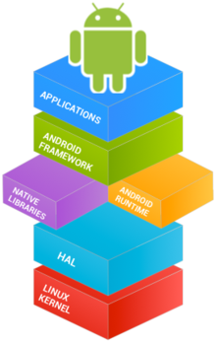

History of android versions
Code name | Version number | Initial release date | API level | Security patches
(No codename) | 1.0 | September 23, 2008 | 1 | Unsupported
(Internally known as "Petit Four") | 1.1 | February 9, 2009 | 2 | Unsupported
Cupcake | 1.5 | April 27, 2009 | 3 | Unsupported
Donut | 1.6 | September 15, 2009 | 4 | Unsupported
Eclair | 2.0 – 2.1 | October 26, 2009 | 5 – 7 | Unsupported
Froyo | 2.2 – 2.2.3 | May 20, 2010 | 8 | Unsupported
Gingerbread | 2.3 – 2.3.7 | December 6, 2010 | 9 – 10 | Unsupported
Honeycomb | 3.0 – 3.2.6 | February 22, 2011 | 11 – 13 | Unsupported
Ice Cream Sandwich | 4.0 – 4.0.4 | October 18, 2011 | 14 – 15 | Unsupported
Jelly Bean | 4.1 – 4.3.1 | July 9, 2012 | 16 – 18 | Unsupported
KitKat | 4.4 – 4.4.4 | October 31, 2013 | 19 – 20 | Unsupported
Lollipop | 5.0 – 5.1.1 | November 12, 2014 | 21 – 22 | 5.1.x Supported
Marshmallow | 6.0 – 6.0.1 | October 5, 2015 | 23 | Supported
Nougat | 7.0 – 7.1.2 | August 22, 2016 | 24 – 25 | Supported
Oreo | 8.0 – 8.1 | August 21, 2017 | 26 – 27 | Supported

Android growth in device activations
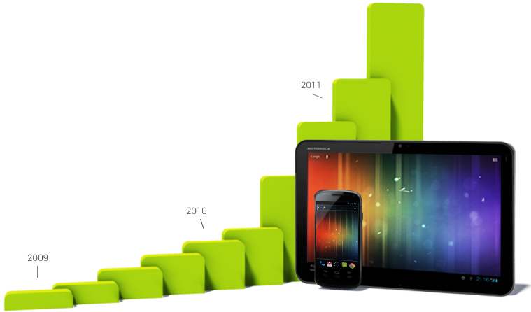

2.3.2 ANDROID VERSION 2.3.3
1. Software Compatibility
The Android platform includes a set of managed APIs, a set of native APIs, and a body of so-called "soft" APIs such as the Intent system and web-application APIs. This section details the hard and soft APIs that are integral to compatibility, as well as certain other relevant technical and user interface behaviors. Device implementations MUST comply with all the requirements in this section.
API Compatibility
Managed API Compatibility
The managed execution environment is the primary vehicle for Android applications. The Android application programming interface (API) is the set of Android platform interfaces exposed to applications running in the managed VM environment. Device implementations MUST provide complete implementations, including all documented behaviors, of any documented API exposed by the Android 2.3 SDK.
Device implementations MUST NOT omit any managed APIs, alter API interfaces or signatures, deviate from the documented behavior, or include no-ops, except where specifically allowed by this Compatibility Definition.
This Compatibility Definition permits some types of hardware for which Android includes APIs to be omitted by device implementations. In such cases, the APIs MUST still be present and behave in a reasonable way.
Intent Compatibility
Android uses Intents to achieve loosely-coupled integration between applications. This section describes requirements related to the Intent patterns that be honored by device implementations.
By "honored", it is meant that the device implementer provide an Android Activity or Service that specifies a matching Intent filter and binds to and implements correct behavior for each specified Intent pattern.
The following applications are considered core Android system applications:

- Desk Clock
- Browser
- Calendar
- Calculator
- Contacts
- Email
- Gallery
- Global Search
- Launcher
- Music
- Settings
The core Android system applications include various Activity, or Service components that are considered "public". That is, the attribute "android: exported" may be absent, or may have the value "true".
Web Compatibility
Many developers and applications rely on the behavior of the android. webkit, webview class for their user interfaces, so the WebView implementation must be compatible across Android implementations. Similarly, a complete, modern web broswer is central to the Android user experience. Device implementations MUST include a version of android.webkit.WebView consistent with the upstream Android software, and MUST include a modern HTML5-.
Browser Compatibility
Device implementations MUST include a standalone Browser application for general user web browsing. The standalone Browser MAY be based on a browser technology other than WebKit. However, even if an alternate Browser application is used, the android.webkit.WebView component provided to third-party applications MUST be based on WebKit,
Software Compatibility Testing
The Android Open-Source Project includes various testing tools to verify that device implementations are compatible. Device implementations MUST pass all tests described in this section.
However, note that no software test package is fully comprehensive. For this reason, device implementers are very strongly encouraged to make the minimum number of changes as possible to the reference and preferred implementation of Android 2.3 available from the Android Open-Source Project. This will minimize the risk of introducing bugs that create incompatibilities requiring rework and potential device updates.
2. Hardware Compatibility
Android is intended to enable device implementers to create innovative form factors and configurations. At the same time Android developers write innovative applications that rely on the various hardware and features available through the Android APIs. The requirements in this section strike a balance between innovations available to device implementers, and the needs of developers to ensure their apps are only available to devices where they will run properly.
If a device includes a particular hardware component that has a corresponding API for third-party developers, the device implementation. implement that API as described in the Android SDK documentation. If an API in the SDK interacts with a hardware component that is stated to be optional and the device implementation does not possess that component:
Complete class definitions (as documented by the SDK) for the component's APIs still be present
The API's behaviors implemented as no-ops in some reasonable fashion
API methods return null values where permitted by the SDK documentation
API methods return no-op implementations of classes where null values are not permitted by the SDK documentation
API methods not throw exceptions not documented by the SDK documentation
Display and Graphics
Android 2.3 includes facilities that automatically adjust application assets and UI layouts appropriately for the device, to ensure that third-party applications run well on a variety of hardware configurations. Devices properly implement these APIs and behaviors, as detailed in this section.
Screen Configurations
Device implementations use screens of any pixel dimensions, provided that they meet the following requirements:

- screen at least 2.5 inches in physical diagonal size
- density at least 100 dpi
- the aspect ratio be between 1.333 (4:3) and 1.779 (16:9)
- the display technology used consists of square pixels
Device implementations with a screen meeting the requirements above are considered compatible, and no additional action is necessary. The Android framework implementation automatically computes display characteristics such as screen size bucket and density bucket. In the majority of cases, the framework decisions are the correct ones. If the default framework computations are used, no additional action is necessary.
Device implementations use only displays with a single static configuration. That is, device implementations not enable multiple screen configurations. For instance, since a typical television supports multiple resolutions such as 1080p, 720p, and so on, this configuration is not compatible with Android 2.3.

Screen Orientation
Compatible devices support dynamic orientation by applications to either portrait or landscape screen orientation. That is, the device must respect the application's request for a specific screen orientation. Device implementations select either portrait or landscape orientation as the default. Devices that cannot be physically rotated meet this requirement by "letterboxing" applications that request portrait mode, using only a portion of the available display.
Input Devices
Android 2.3 supports a number of modalities for user input. Device implementations support user input devices as provided for in this section.
Keyboard
Device implementations:
- It include support for the Input Management Framework (which allows third party developers to create Input Management Engines - i.e. soft keyboard) as detailed at developer.android.com
- It provide at least one soft keyboard implementation (regardless of whether a hard keyboard is present)
- It include additional soft keyboard implementations
- It include a hardware keyboard
- It Include a hardware keyboard that does not match one of the formats specified in android.content.res.Configuration.keyboard
Data Connectivity
Network connectivity and access to the Internet are vital features of Android. Meanwhile, device-to-device interaction adds significant value to Android devices and applications. Device implementations MUST meet the data connectivity requirements in this section.
IEEE 802.11 (WiFi )
Android 2.3 device implementations include support for one or more forms of 802.11 (b/g/a/n, etc.) If a device implementation does include support for 802.11, it implement the corresponding Android API.
Bluetooth
Device implementations include a Bluetooth transceiver. Device implementations that do include a Bluetooth transceiver enable the RFCOMM-based Bluetooth API as described in the SDK documentation. Device implementations implement relevant Bluetooth profiles, such as A2DP, AVRCP, OBEX, etc. as appropriate for the device.
The Compatibility Test Suite includes cases that cover basic operation of the Android RFCOMM Bluetooth API. However, since Bluetooth is a communications protocol between devices, it cannot be fully tested by unit tests running on a single device. Consequently, device implementations also pass the human-driven Bluetooth test procedure described in Appendix A.
Minimum Network Capability
Device implementations include support for one or more forms of data networking. Specifically, device implementations include support for at least one data standard capable of 200Kbit/sec or greater. Examples of technologies that satisfy this requirement include EDGE, HSPA, EV-DO, 802.11g, Ethernet, etc.
Device implementations where a physical networking standard (such as Ethernet) is the primary data connection also include support for at least one common wireless data standard, such as 802.11 (WiFi).
Cameras
Device implementations include a rear-facing camera, and include a front-facing camera. A rear-facing camera is a camera located on the side of the device opposite the display; that is, it images scenes on the far side of the device, like a traditional camera. A front-facing camera is a camera located on the same side of the device as the display; that is, a camera typically used to image the user, such as for video conferencing and similar applications.
Rear-Facing Camera
Device implementations include a rear-facing camera. If a device implementation includes a rear-facing camera, it:
- It have a resolution of at least 2 megapixels
- It have either hardware auto-focus, or software auto-focus implemented in the camera driver (transparent to application software)
- They have fixed-focus or EDOF (extended depth of field) hardware
- It include a flash. If the Camera includes a flash, the flash lamp is not be lit while an android, hardware, Camera. Preview Callback instance has been registered on a Camera preview surface, unless the application has explicitly enabled the flash by enabling the FLASH_MODE_AUTO or FLASH_MODE_ON attributes of a Camera. Parameters object. Note that this constraint does not apply to the device's built-in system camera application, but only to third-party applications using Camera. Preview Callback.

Front-Facing Camera
Device implementations include a front-facing camera. If a device implementation includes a front-facing camera, It have a resolution of at least VGA (that is, 640x480 pixels)
It is not use a front-facing camera as the default for the Camera API. That is, the camera API in Android 2.3 has specific support for front-facing cameras, and device implementations is not configure the API to to treat a front-facing camera as the default rear-facing camera, even if it is the only camera on the device.
Camera Orientation
Both front- and rear-facing cameras, if present, MUST be oriented so that the long dimension of the camera aligns with the screen's long dimention. That is, when the device is held in the landscape orientation, a cameras capture images in the landscape orientation. This applies regardless of the device's natural orientation; that is, it applies to landscape-primary devices as well as portrait-primary devices.
Memory and Storage
The fundamental function of Android 2.3 is to run applications. Device implementations requirements of this section, to ensure adequate storage and memory for applications to run properly.
Minimum Memory and Storage
Device implementations have at least 128MB of memory available to the kernel and userspace. The 128MB in addition to any memory dedicated to hardware components such as radio, memory, and so on that is not under the kernel's control.
Device implementations at least 150MB of non-volatile storage available for user data. That is, the /data partition at least 150 MB.
The Android APIs include a Download Manager that applications may use to download data files. The Download Manager implementation capable of downloading individual files 55MB in size, or larger. The Download Manager implementation be capable of downloading files 100 MB in size, or larger.
Application Shared Storage
Device implementations offer shared storage for applications. The shared storage c x c0078 provided at least 1GB in size.
Device implementations configured with shared storage mounted by default, "out of the box". If the shared storage is not mounted on the Linux path /sdcard, then the device include a Linux symbolic link from /sdcard to the actual mount point.
USB
Device implementations:
- It implement a USB client, connectable to a USB host with a standard USB-A port
- It implement the Android Debug Bridge over USB
- It implement the USB mass storage specification, to allow a host connected to the device to access the contents of the /sdcard volume use the micro USB form factor on the device side
- MAY include a non-standard port on the device side, but if so ship with a cable capable of connecting the custom pinout to standard USB-A port.

Security Model Compatibility
Device implementations implement a security model consistent with the Android platform security model as defined in Security and Permissions reference document in the APIs in the Android developer documentation. Device implementations support installation of self-signed applications without requiring any additional permissions/certificates from any third parties/authorities. Specifically, compatible devices support the security mechanisms described in the follow sub-sections.
2.3.3 SQL (Structured Query Language)
SQL stands for Structured Query Language and is the standard relational language that is supported by just about every database product. All database professionals should know how to write, troubleshoot, and optimize SQL.
Our tutorial will start with the basics of SQL, such as how to retrieve and manipulate data. Then we will move to the more advanced topics such as how to create tables and views.
With this tutorial, you should be on your way to becoming proficient in writing, executing, and optimizing SQL.
Data Definition Language (DDL)
The Data Definition Language (DDL) manages table and index structure. The most basic items of DDL are the CREATE, ALTER, RENAME and DROP statements:
- CREATE creates an object (a table, for example) in the database.
- DROP deletes an object in the database, usually irretrievably.
- ALTER modifies the structure an existing object in various ways for example, adding a column to an existing table.
Data Manipulation Language (DML)
- The Data Manipulation Language (DML) is the subset of SQL used to add, update and delete data.
- The acronym CRUD refers to all of the major functions that need to be implemented in a relational database application to consider it complete. Each letter in the acronym can be mapped to a standard SQL statement

Operation |  | SQL | Description
Create | INSERTINTO |  | Inserts new data into a database
Read (Retrieve) | SELECT |  | Extracts data from a database
Update | UPDATE |  | Updates data in a database
Delete (Destroy) | DELETE |  | Deletes data from a database

What is SQL?
- SQL stands for Structured Query Language
- SQL lets you access and manipulate databases
- SQL is an ANSI (American National Standards Institute) standard
What Can SQL do?
- SQL can execute queries against a database
- SQL can retrieve data from a database
- SQL can insert records in a database
- SQL can update records in a database
- SQL can delete records from a database
- SQL can create new databases
- SQL can create new tables in a database
- SQL can create stored procedures in a database
- SQL can create views in a database
- SQL can set permissions on tables, procedures, and views.
RDBMS
- RDBMS stands for Relational Database Management System.
- RDBMS is the basis for SQL, and for all modern database systems such as MS SQL Server, IBM DB2, Oracle, MySQL, and Microsoft Access.
- The data in RDBMS is stored in database objects called tables. A table is a collection of related data entries and it consists of columns and rows.
The Most Important SQL Commands
SELECT - extracts data from a database
UPDATE - updates data in a database
DELETE - deletes data from a database
INSERT INTO - inserts new data into a database
CREATE DATABASE - creates a new database
ALTER DATABASE - modifies a database
CREATE TABLE - creates a new table
ALTER TABLE - modifies a table
DROP TABLE - deletes a table
CREATE INDEX - creates an index (search key)
DROP INDEX - deletes an index
SQL Usage
- To execute queries against a database
- To retrieve data from a database
- To inserts records in a database
- To updates records in a database
- To delete records from a database
- To create new databases
- To create new tables in a database
- To create views in a database
SQL Constraints
Constraints are used to limit the type of data that can go into a table.
Constraints can be specified when a table is created (with the CREATE TABLE statement) or after the table is created (with the ALTER TABLE statement).
Here are the most important constraints:
- PRIMARY KEY
- NOT NULL
- UNIQUE
- FOREIGN KEY
- CHECK
- DEFAULT
Identity
In the sections below we will explain some of these in detail.
Primary Key
A primary key is a combination of fields which uniquely specify a row. This is a special kind of unique key. Primary key values cannot be NULL.
Foreign Key
A foreign key is specified as a key which is related to the primary key of another table. Relationship needs to be created between two tables by referencing foreign key with the primary key of another table.
NOT NULL / Required Columns
The NOT NULL constraint enforces a column to NOT accept NULL values. The NOT NULL constraint enforces a field to always contain a value. This means that you cannot insert a new record, or update a record without adding a value to this field.
Unique
A Unique key constraint uniquely identifies each record in the database. This provides uniqueness for the column or set of columns.
Check
The CHECK constraint is used to limit the value range that can be placed in a column. If you define a CHECK constraint on a single column it allows only certain values for this column. If you define a CHECK constraint on a table it can limit the values in certain columns based on values in other columns in the row.

Default
The DEFAULT constraint is used to insert a default value into a column. The default value will be added to all new records, if no other value is specified.
Auto Increment (or) Identity
Very often we would like the value of the primary key field to be created automatically every time a new record is inserted.
SQL Index
Index is used to increase the performance and allow faster retrieval of records from the table. An index creates an entry for each value and it will be faster to retrieve data.
There are three types of Indexes in SQL:
- Unique Index
- Clustered Index
- Non Clustered Index
- Unique Index:
This indexing does not allow the field to have duplicate values if the column is unique indexed. Unique index can be applied automatically when primary key is defined.
- Clustered Index:
The clustered index is used to reorder the physical order of the table and search based on the key values. Each table can have only one clustered index.

- Non Clustered Index:
Non Clustered Index does not alter the physical order of the table and maintains logical order of data. Each table can have 999 non-clustered indexes.

CHAPTER 5
SYSTEM DESIGN AND DEVELOPMENT

System Design
The system design is divided in to the six main module
They are,
    - OverView
    - Basic Queries
    - Advance Queries
    - Functions And Fillters
    - Interview Questions
    - Run Queries
    - Quiz

- OverView
This module shows the overall description of SQL. SQL is used for back end database in the projects. SQL details are in the over view concept. Overview contains the introduction of SQL, categories of SQL statements of DDL,DML,DCL,TCL.
It contains Inserting, updating, deleting, creating, replacing, altering, dropping objects. RDBMS is stands for relational database management system in RDBMS the data is stored in tables which are in the form of rows and columns. RDBMS is defined by the codd’s 12 rules such as
RULES:
      - The information rule
      - The guaranteed access rule
      - Systematic treatment of null values
      - Active online catalog based on the relational model
      - The comprehensive data sublanguage rule
      - The view updating rule
      - High level insert, update and delete
      - Physical data independence
      - Logical data independence
      - Integrity independence
      - Distribution independence
      - The non-subversion rule

- Basic Queries
In this module is used for learning the basic concepts.it should display the following basic queries,
      - CREATE_DB
      - CREATE_TABLE
      - SELECT
      - UPDATE
      - DELETE
      - WHERE
      - DISTIN
SYNTAX FOR BASIC QUERIES
Create_db :
CREATE DATABASE database_ name
Create_table :
CREATE TABLE table_ name
(
Column_name1 data_ type,
Column_name2 data_ type,
Column_name3 data_ type,
……
)
Insert :
INSERT INTO table_ name
VALUES(value1,value2,value3…..)
Select:
SELECT column_ name(s)
FROM table_ name
Update:
UPDATE table_ name
SET column1=value, column2=value2,…
WHERE some_ column=some_ value
Delete:
DELETE FROM table_ name
WHERE some_ column=some_ value
Where:
SELECT column_ name(s) FROM table_ name
WHERE column_ name operator value
Distinct:
SELECT DISTINCT column_ name(s) RROM table_ name

- Advance Queries
In this module is used for learning the advance concept. It should display the following advance queries,
    - ALTER
    - ALIAS
    - BETWEEN
    - CASE
    - CHECK
    - DEFAULT
    - DROP
    - LIKE etc
SYNTAX FOR THE ADVANCE QUERIES
Alter:
ALTER TABLE table_ name
ADD column datatype
Alias:
SELECT column_ name (S) FROM table_ name AS alias_ name
Between:
SELECT column_ name(s) FROM table_ name WHERE column_name
BETWEEN value1 AND value2
Case:
CASE column_ name WHEN condition THEN result
ELSE result_2
END
Check:
ALTER TABLE persons ADD check (p_Id>0)
Default:
ALTER TABLE persons
ALTER city SET DEFAULT ‘SANDER’
Drop:
DROP INDEX index_ name ON table _ name
Like:
SELECT column_ name(s) FROM table_ name
WHERE column_ name LIKE pattern
- SQL Functions
In this module is used for learning SQL functions. It should display the following SQL function,
    - AND & OR ()
    - AVG ()
    - COUNT ()
    - FIRST ()
    - FORMAT ()
    - MAX ()
    - MIN ()
    - SUM ()
SYNTAX FOR SQL FUNCTIONS
And & or ():
SELECT * FROM persons WHERE
Last name=’Jameson ‘
AND (first name=’John’ OR First name=’Kate’)
Avg ():
SELECT AVG (column_ name) FROM table_ name

Count ():
SELECT COUNT (column_ name) FROM table_ name
First ():
SELECT FIRST (column_ name) FROM table_ name
Format ():
SELECT FORMAT (column_ name, format) FROM
Table_ name
Max ():
SELECT MAX (column_ name) FROM table_ name
Min ():
SELECT MIN (column_ name) FROM table_ name
Sum ():
SELECT SUM (column_ name) FROM table_ name

- Interview Questions
This module shows the interview questions about the SQL statements and relational database management system. This will help to knowing the level of learning SQL.some of the interview questions are,
1. What is the difference between UNION and UNIONALL?
2. What is the difference between TRUNCATE and DELETE commands?
3. What is self-join?
4 .what is primary key?
5. what is a candidate key?
6. what is stored procedure?
7.how will you raise an error in SQL?
8. explain about tokens?
9. what is BCNF?
10. what is functional dependency?

- Run Queries
In case doubt is occur, While learning SQL we can run the queries. This module shows the result of input queries, and also we can edit the basic queries of INSERT,UPDATE,CREATE,DELETE.
- Quiz
This module display some of the quiz question related to the SQL statements ,there is a time limit for every quiz question if the time is left, it will move on to the next question . finally the result activity such as correct answer, wrong answer, no of question you attend will display

CHAPTER 6
CONCLUSION & FUTURE ENHANCEMENTS

6.1 Conclusion

SQL Learning Project generally used to Education Oriented. In this Projects helps to the students and SQL Language Readers Easy to understand and developing our knowledge in this projects.

6.2 Future Enhancements
After analyzing the test results of the developed systems, the following issues are still open which can be taken up as future enhancements.
As Android phones are widely used everywhere, it is obvious that applications like these offer simple solutions to do our daily activities. These Android applications can be used in future to manage not only college buses but also the vehicles that belong to the institution. These applications can also be used in any other domain to carry out fleet management efficiently.
The proposed system can further be enhanced by making use of it in BMTC bus tracking systems and also to report accidents and help in traffic monitoring. It can also be made compatible with IOS and Windows OS supporting systems

CHAPTER 7
APPENDIX
7.1 TABLE DESIGN
SQL Concepts
S.No | Categories | Data Type
1 | Over View | Varchar(20)
2 | Basic Queries | Varchar(20)
3 | Advance Queries | Varchar(20)
4 | Function And Fillters | Varchar(20)
5 | Interview Questions | Varchar(20)
6 | Run Queries | Varchar(20)
7 | Sample Queries | Varchar(20)

S.  No | Questions | Option A | Option B | Option C | Option D | Answer
1 | What does SQL stand for? | Strong Question Language | Structured Questions Language | Structured Query Language | Structured Query Language | Structured Query Language
2 | Which SQL statement is used to update data in a database? | SAVE | MODIFY | UPDATE | SAVE AS | UPDATE
3 | Which SQL keyword is used to retrieve only unique values? | DIFFRENT | DISTINCT | DISTINCT | UNIQUE | DISTINCT

Interview Question
S.No | Fields | Data Type
1 | Questions | Varchar
2 | Option A | Varchar
3 | Option B | Varchar
4 | Option C | Varchar
5 | Option D | Varchar
6 | Answer | Varchar

7.2 MODULE BLOCK DIAGRAM
User

Overview

Data Base
Start App

Basic Queries

Advance Queries

Functions And Filters

Load Data

Run Queries

Interview Questions

Quiz

Sample Queries

Working area

Start Quiz
Output
Working area

Data
Base

7.3 Screen Shots
SQL

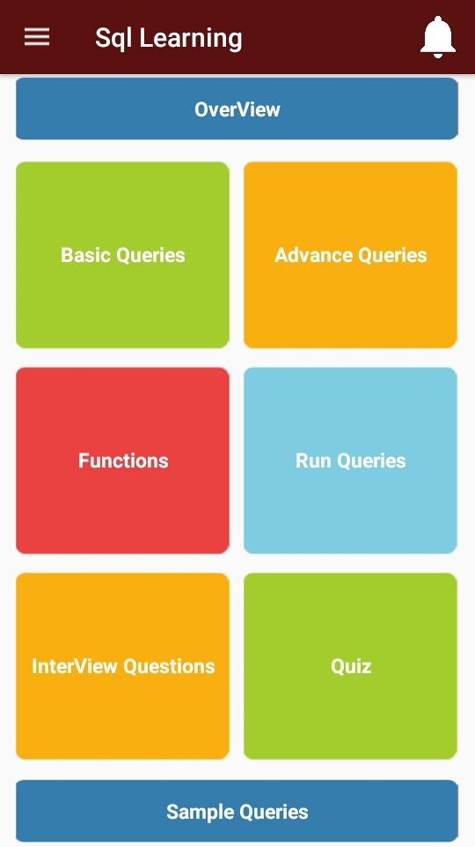

Overview

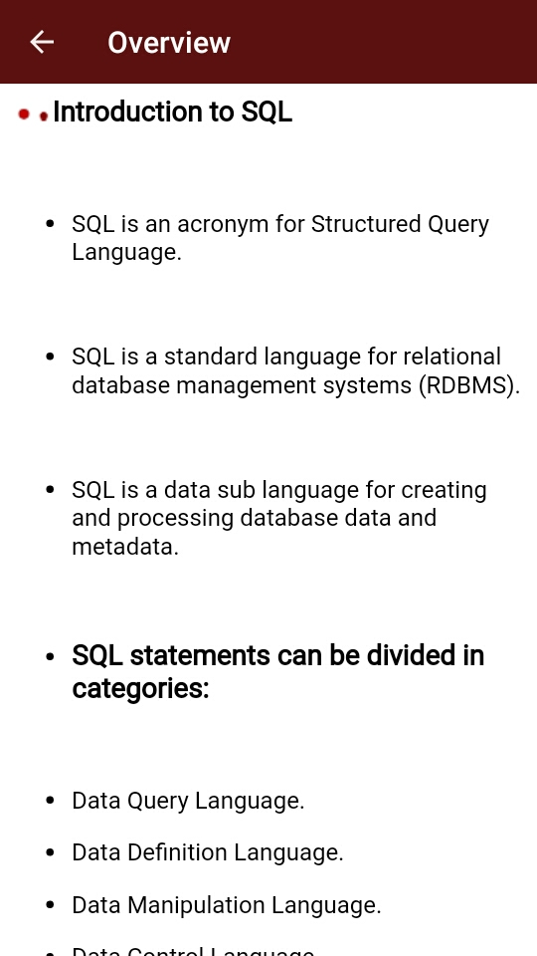

Basic Queries

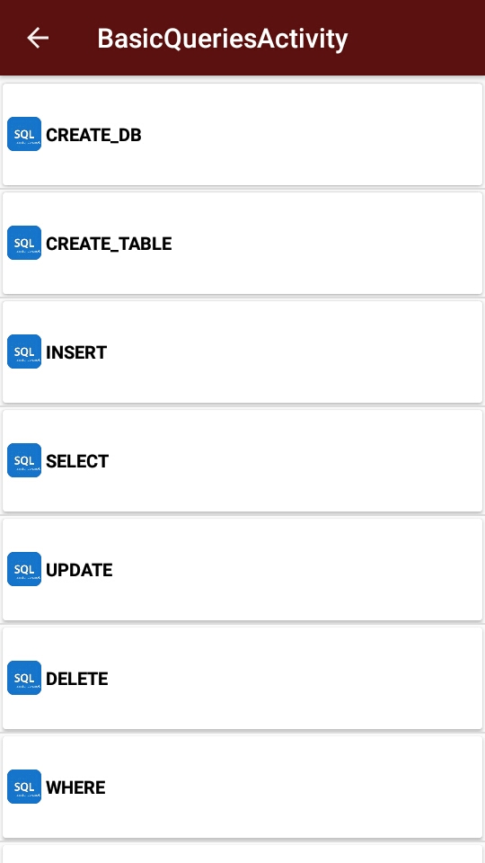

Advance Queries

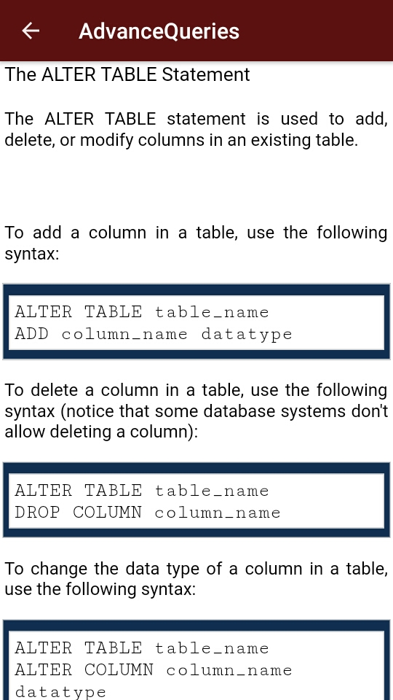

Sql Functions

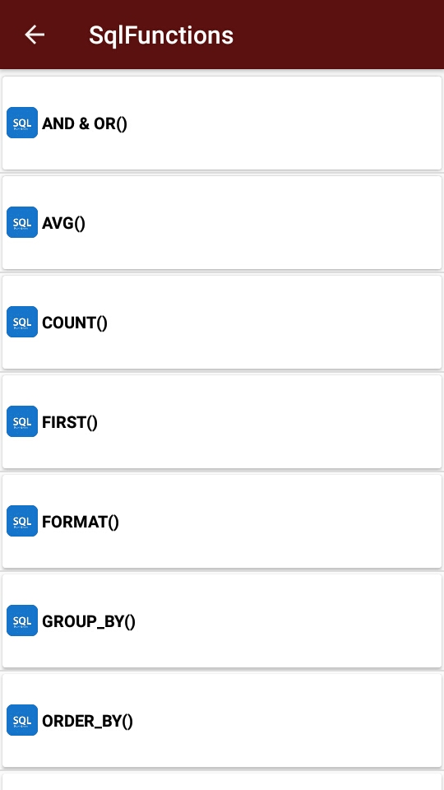

Run Queries

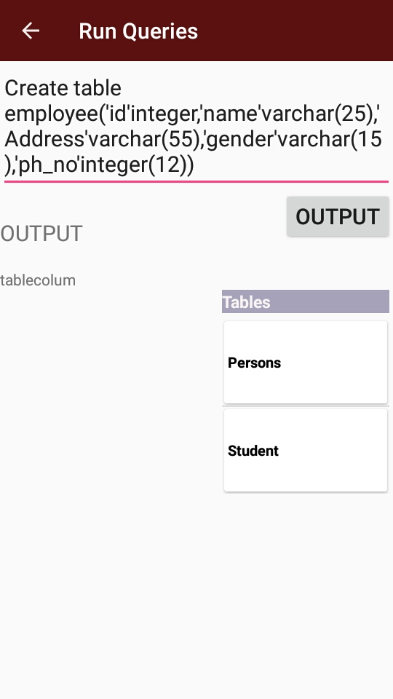

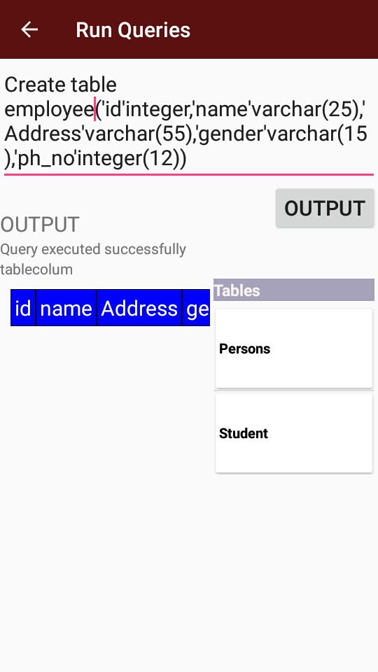

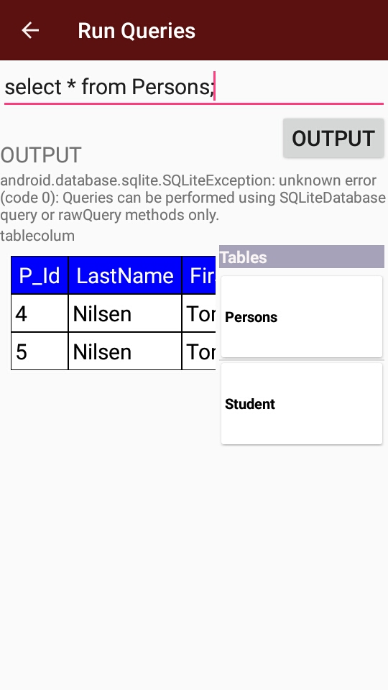

Interview Questions

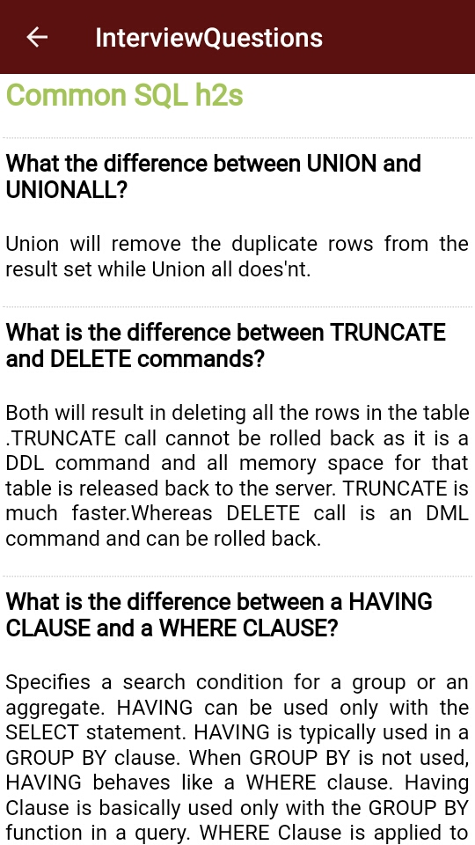

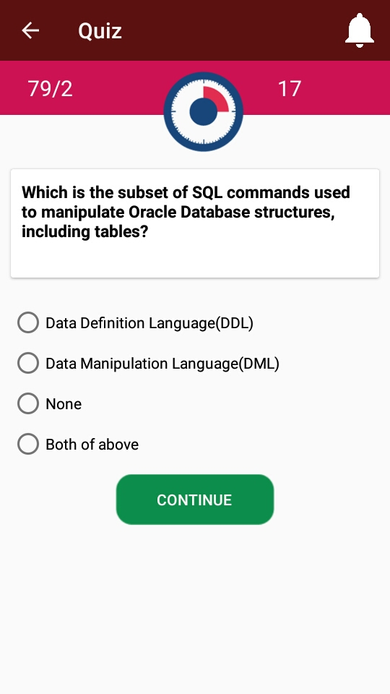

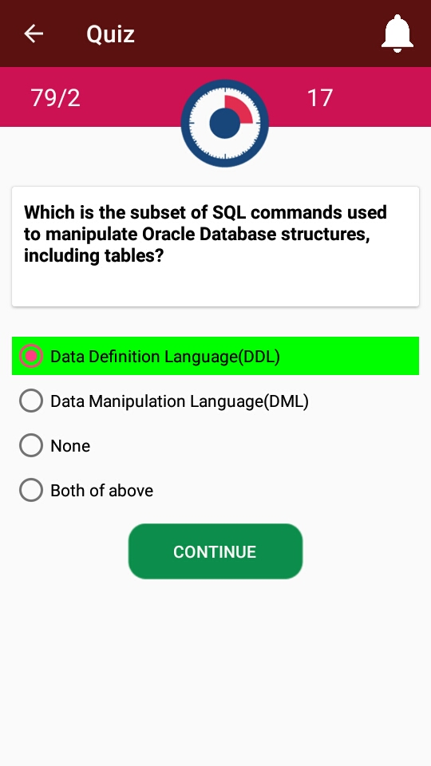

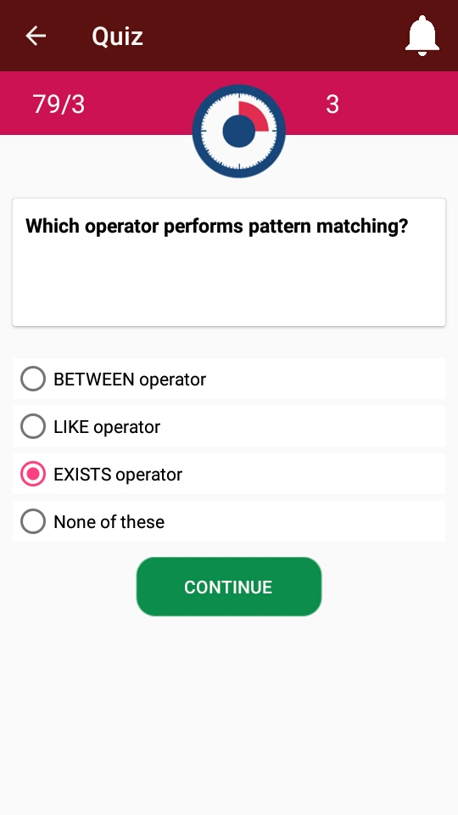
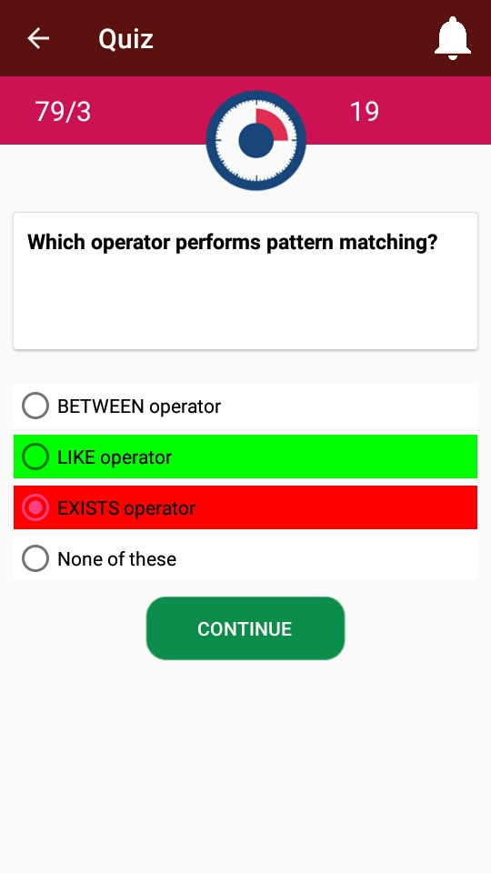

Output

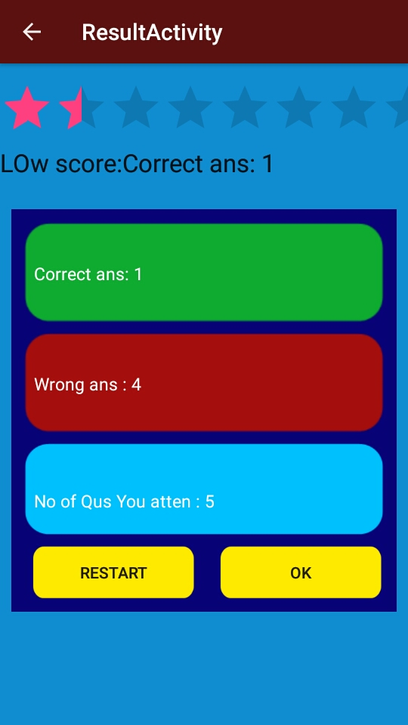

Sample Queries

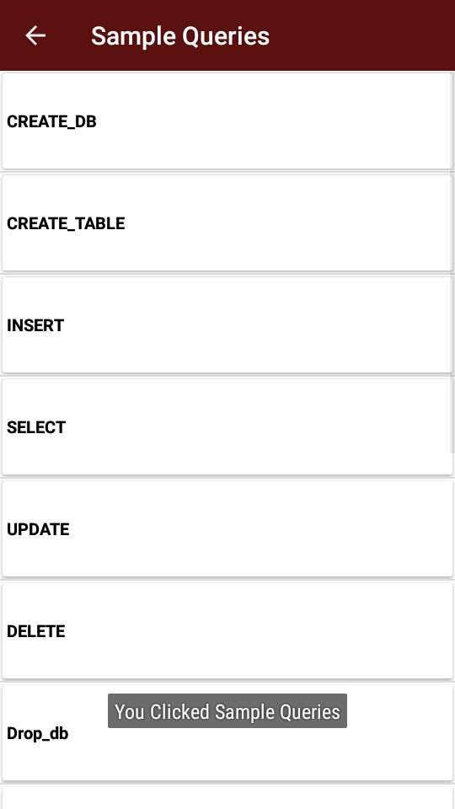

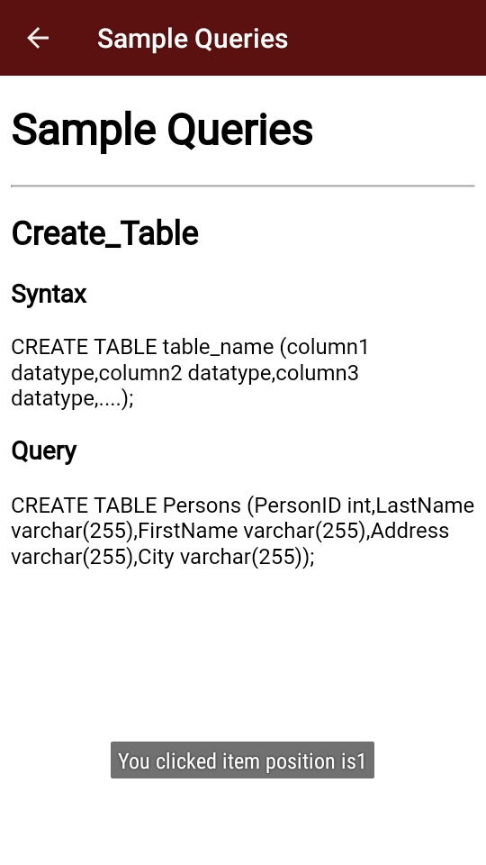

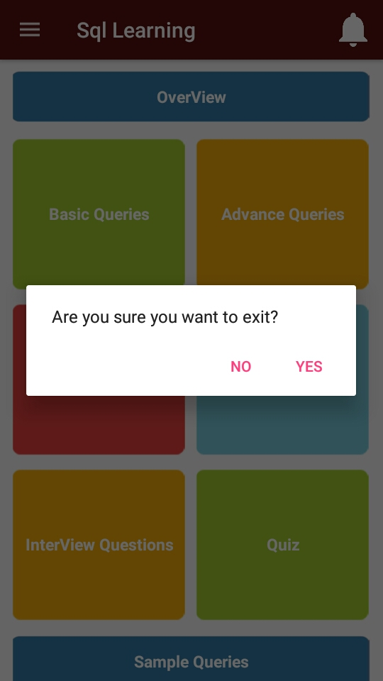

7.4 Source Code
SQL

import android.content.ActivityNotFoundException;
import android.content.Context;
import android.content.DialogInterface;
import android.content.Intent;
import android.database.sqlite.SQLiteDatabase;
import android.graphics.Typeface;
import android.net.Uri;
import android.os.Build;
import android.os.Bundle;
import android.os.Handler;
import android.support.design.widget.NavigationView;
import android.support.v4.view.GravityCompat;
import android.support.v4.widget.DrawerLayout;
import android.support.v7.app.ActionBarDrawerToggle;
import android.support.v7.app.AlertDialog;
import android.support.v7.app.AppCompatActivity;
import android.support.v7.widget.Toolbar;
import android.view.MenuItem;
import android.view.View;
import android.widget.ListAdapter;
import android.widget.ListView;
import android.widget.TextView;
import java.io.IOException;
import java.sql.SQLException;
public class MainActivity extends AppCompatActivity implements NavigationView.OnNavigationItemSelectedListener{
TextView ovw,bc,ac,fun,qus,ery,txt;
SQLiteDatabase db;
SharedPreference sp;
DataBaseHelper dataBaseHelper;
static final int INTERNAL_EMPTY_ID = 16711681;
static final int INTERNAL_LIST_CONTAINER_ID = 16711683;
static final int INTERNAL_PROGRESS_CONTAINER_ID = 16711682;
ListAdapter mAdapter;
CharSequence mEmptyText;
View mEmptyView;
private final Handler mHandler = new Handler();
ListView mList;
View mListContainer;
boolean mListShown;
/*private final AdapterView.OnItemClickListener mOnClickListener = new C00232();
View mProgressContainer;
private final Runnable mRequestFocus = new C00221();*/
TextView mStandardEmptyView;
@Override
protected void onCreate(Bundle savedInstanceState) {
super.onCreate(savedInstanceState);
setContentView(R.layout.activity_main);
Toolbar toolbar = (Toolbar) findViewById(R.id.toolbar);
setSupportActionBar(toolbar);
dataBaseHelper=new DataBaseHelper(MainActivity.this);
DrawerLayout drawer = (DrawerLayout) findViewById(R.id.drawer_layout);
ActionBarDrawerToggle toggle = new ActionBarDrawerToggle(
this, drawer, toolbar, R.string.navigation_drawer_open, R.string.navigation_drawer_close);
drawer.setDrawerListener(toggle);
toggle.syncState();
NavigationView navigationView = (NavigationView) findViewById(R.id.nav_view);
navigationView.setNavigationItemSelectedListener(this);
sp=new SharedPreference();
db=openOrCreateDatabase("Sqledit.db",Context.MODE_PRIVATE,null);
//db.execSQL("create table");
ovw= (TextView) findViewById(R.id.sql_maintxt1);
bc= (TextView) findViewById(R.id.sql_maintxt2);
ac= (TextView) findViewById(R.id.sql_maintxt3);
txt= (TextView) findViewById(R.id.sql_maintxt8);
fun= (TextView) findViewById(R.id.sql_maintxt7);
qus= (TextView) findViewById(R.id.sql_maintxt5);
ery= (TextView) findViewById(R.id.sql_maintxt6);
Typeface custom_font=Typeface.createFromAsset(getAssets(),"font/font.ttf");
ovw.setTypeface(custom_font);
bc.setTypeface(custom_font);
ac.setTypeface(custom_font);
txt.setTypeface(custom_font);
fun.setTypeface(custom_font);
qus.setTypeface(custom_font);
ery.setTypeface(custom_font);
ovw.setOnClickListener(new View.OnClickListener() {
@Override
public void onClick(View v) {
Intent in=new Intent(getApplicationContext(),OverviewActivity.class);
startActivity(in);
}
});
bc.setOnClickListener(new View.OnClickListener() {
@Override
public void onClick(View v) {
Intent in2=new Intent(getApplicationContext(),BasicConceptsActivity.class);
startActivity(in2);
}
});
ac.setOnClickListener(new View.OnClickListener() {
@Override
public void onClick(View v) {
Intent in3=new Intent(getApplicationContext(),AdvanceConceptActivity.class);
startActivity(in3);
}
});
System.out.println("" + ioe + "Unable to create database");
throw new Error("Unable to create database");
}
try {
dataBaseHelper.openDataBase();
} catch (SQLException e) {
e.printStackTrace();
}
System.out.println("openDataBase");
sp.putInt(getApplicationContext(), "db_move", 1);
}
}
alertDlg.setNegativeButton("No",new DialogInterface.OnClickListener() {
@Override
public void onClick(DialogInterface dialog, int which) {
// We do nothing
}
});
alertDlg.create().show();
}
}
getResources().getString(R.string.share_using)));
}
DrawerLayout drawer = (DrawerLayout) findViewById(R.id.drawer_layout);
drawer.closeDrawer(GravityCompat.START);
return true;
}
public void rateApp()
{
try
{
Intent rateIntent = rateIntentForUrl("market://details");
startActivity(rateIntent);
}
catch (ActivityNotFoundException e)
{
Intent rateIntent = rateIntentForUrl("https://play.google.com/store/apps/details");
startActivity(rateIntent);
}
}
private Intent rateIntentForUrl(String url)
{
Intent intent = new Intent(Inteznt.ACTION_VIEW, Uri.parse(String.format("%s?id=%s", url, getPackageName())));
int flags = Intent.FLAG_ACTIVITY_NO_HISTORY | Intent.FLAG_ACTIVITY_MULTIPLE_TASK;
if (Build.VERSION.SDK_INT >= 21)
{
flags |= Intent.FLAG_ACTIVITY_NEW_DOCUMENT;
}
else
{
//noinspection deprecation
flags |= Intent.FLAG_ACTIVITY_CLEAR_WHEN_TASK_RESET;
}
intent.addFlags(flags);
return intent;
}
/*private void feedback() {
final Dialog dialog1 = new Dialog(MainActivity.this,android.R.style.Theme_DeviceDefault_Light_Dialog_NoActionBar_MinWidth);
dialog1.setContentView(R.layout.feedback);
TextView txtfd=(TextView)dialog1.findViewById(R.id.txtfd);
final EditText edtfbk= (EditText) dialog1.findViewById(R.id.edtfbk);
Button send = (Button) dialog1.findViewById(R.id.send);
InputMethodManager imm1 = (InputMethodManager) getSystemService(Context.INPUT_METHOD_SERVICE);
imm1.toggleSoftInput(InputMethodManager.SHOW_FORCED, 0);
send.setOnClickListener(new View.OnClickListener() {
@Override
public void onClick(View v) {
if (edtfbk.getText().toString().length() == 0) {
Toast.makeText(MainActivity.this, "Please type your feedback or suggestion, Thank you", Toast.LENGTH_SHORT).show();
}
else {
Toast.makeText(MainActivity.this, "Thank you", Toast.LENGTH_SHORT).show();
dialog1.cancel();
}*//*else {
if (Utils.isNetworkAvailable(MainActivity.this)) {
final Handler handler = new Handler() {
public void handleMessage(NotificationCompat.MessagingStyle.Message msg) {
Runnable runnable = new Runnable() {
public void run() {
}
};
runOnUiThread(runnable);
}
};
Thread checkUpdate = new Thread() {
public void run() {
try {
send_feedback(edtfbk.getText().toString());
} catch (Exception e) {
}
handler.sendEmptyMessage(0);
}
private void send_feedback(String s) {
}
};
checkUpdate.start();
Toast.makeText(MainActivity.this, "Feedback sent, Thank you",Toast.LENGTH_SHORT).show();
dialog1.dismiss();*//*
}*//*
InputMethodManager inputMethodManager = (InputMethodManager) getSystemService(INPUT_METHOD_SERVICE);
inputMethodManager.hideSoftInputFromWindow(getCurrentFocus().getWindowToken(), 0);
} else {
Toast.makeText(MainActivity.this, "Hey buddy, connect to the network",Toast.LENGTH_SHORT).show();
}
}*//**//*
*//*
});
dialog1.show();
}*/
/*public static void writeReviewMail() {
Context context = null;
Intent emailIntent = new Intent(Intent.ACTION_SENDTO, Uri.fromParts(
"mailto", "youremail@example.com", null));
emailIntent.putExtra(Intent.EXTRA_SUBJECT, context.getString(R.string.yoursubject));
context.startActivity(Intent.createChooser(emailIntent, context.getString(R.string.contact_us)));
}*/
private boolean sendEmail() {
/*File photo = new File("sdcard/Video Tell Images/" + ViewVideo.saved_image_name);
Uri imageuri = Uri.fromFile(photo);*//*
Intent send_report = new Intent(Intent.ACTION_SENDTO, Uri.fromParts(
"mailto", "youremail@example.com", null));
send_report.setClassName("com.google.android.gm", "com.google.android.gm.ComposeActivityGmail");
send_report.putExtra(Intent.EXTRA_TEXT, "View my image");
send_report.setType("text/plain");
startActivity(send_report);*/
Intent Email = new Intent(Intent.ACTION_SEND);
Email.setType("text/email");
Email.putExtra(Intent.EXTRA_EMAIL, new String[] { "uthaya.2012@gmail.com" });
Email.putExtra(Intent.EXTRA_SUBJECT, "Feedback");
Email.putExtra(Intent.EXTRA_TEXT, "Dear ...," + "");
startActivity(Intent.createChooser(Email, "Send Feedback:"));
return true;
} }

Basic Queries

import android.content.Intent;
import android.os.Bundle;
import android.support.v7.app.AppCompatActivity;
import android.support.v7.widget.Toolbar;
import android.view.View;
import android.view.animation.Animation;
import android.widget.AdapterView;
import android.widget.ListView;
import android.widget.PopupWindow;
import java.util.ArrayList;
public class BasicConceptsActivity extends AppCompatActivity {
Toolbar toolbar;
ListView sql_basatlis;
Animation set;
String value;
String popUpContents[];
static PopupWindow popupWindowDogs;
BasicconceptListAdapter list_adapter;
ArrayList<String> basiccommand=new ArrayList<>();
public static int [] basicimages=new int[]{R.drawable.sqlm1,R.drawable.sqlm1,R.drawable.sqlm1,R.drawable.sqlm1,R.drawable.sqlm1,R.drawable.sqlm1,R.drawable.sqlm1,R.drawable.sqlm1,R.drawable.sqlm1,R.drawable.sqlm1,R.drawable.sqlm1,R.drawable.sqlm1,R.drawable.sqlm1,R.drawable.sqlm1,R.drawable.sqlm1};
@Override
protected void onCreate(Bundle savedInstanceState) {
super.onCreate(savedInstanceState);
setContentView(R.layout.activity_basic_concepts);
toolbar = (Toolbar) findViewById(R.id.toolbar);
toolbar.setNavigationIcon(R.drawable.ic_arrow_back_black_24dp);
setSupportActionBar(toolbar);
toolbar.setNavigationOnClickListener(new View.OnClickListener() {
@Override
public void onClick(View v) {
onBackPressed();
}
});
init();
sql_basatlis.setAdapter(list_adapter);
/*set= AnimationUtils.loadAnimation(getApplicationContext(),R.anim.slidein);
sql_basatlis.startAnimation(set);*/
sql_basatlis.setOnItemClickListener(new AdapterView.OnItemClickListener() {
@Override
public void onItemClick(AdapterView<?> parent, View view, int position, long id) {
Intent in=new Intent(getApplicationContext(),webActivity.class);
}
});
basiccommand.add("CREATE_DB");
basiccommand.add("CREATE_TABLE");
basiccommand.add("DATA_TYPES");
basiccommand.add("DELETE");
basiccommand.add("DISTINCT");
basiccommand.add("GET_STARTED");
basiccommand.add("INSERT");
basiccommand.add("SELECT");
basiccommand.add("SYNTAX");
basiccommand.add("UPDATE");
basiccommand.add("WHERE");
}
private void init() {
//getSupportActionBar().setTitle("List Cards");basicoptionimages,popupWindowDogs
list_adapter = new BasicconceptListAdapter(BasicConceptsActivity.this,basiccommand,basicimages);
sql_basatlis = (ListView) findViewById(R.id.sql_basatlis);
}
}

Interview Questions

public class InterviewqusActivity extends AppCompatActivity {
Toolbar toolbar;
WebView webView;
@Override
protected void onCreate(Bundle savedInstanceState) {
super.onCreate(savedInstanceState);
setContentView(R.layout.activity_interviewqus);
toolbar = (Toolbar) findViewById(R.id.toolbar);
toolbar.setNavigationIcon(R.drawable.ic_arrow_back_black_24dp);
setSupportActionBar(toolbar);
toolbar.setNavigationOnClickListener(new View.OnClickListener() {
@Override
public void onClick(View v) {
onBackPressed();
}
});
webView = (WebView)findViewById(R.id.sql_web_view1);
webView.setWebViewClient(new WebViewClient());
webView.setWebChromeClient(new WebChromeClient());
WebSettings webSettings = webView.getSettings();
webSettings.setBuiltInZoomControls(true);
webView.loadUrl("file:///android_asset/eng/functions/interviewqus.html");
}
}

Quiz

public class QuizActivity extends AppCompatActivity {
//public static String total;
Toolbar toolbar;

List<Question> quesList;
public static int score, correct, wrong, wronganswers, correctanswer, atten,total;
public boolean isCorrect;
static int qid = 0;
int totalCount = 49;
Question currentQ;
TextView txt1, txt2, txt3, txt4;
RadioButton sql_quizrgbtn, sql_quizrgbtn1, sql_quizrgbtn2, sql_quizrgbtn3, sql_quizrgbtn4;
Button btn, btn1;

MediaPlayer mp;
int length;
TextView rt;
boolean nextFlag = false;
boolean isTimerFinished = false;
static LinkedHashMap lhm = new LinkedHashMap();
MyCountDownTimer countDownTimer = new MyCountDownTimer(10000 /* 20 Sec */,
1000);
RadioGroup grp;
@Override
protected void onCreate(Bundle savedInstanceState) {
super.onCreate(savedInstanceState);
setContentView(R.layout.activity_quiz);
toolbar = (Toolbar) findViewById(R.id.toolbar);
toolbar.setNavigationIcon(R.drawable.ic_arrow_back_black_24dp);
setSupportActionBar(toolbar);
toolbar.setNavigationOnClickListener(new View.OnClickListener() {
@Override
public void onClick(View v) {
onBackPressed();
}
});
DataBaseHelper db = new DataBaseHelper(this);
quesList = db.getAllQuestions();
currentQ = quesList.get(qid);
length = quesList.size();

txt1 = (TextView) findViewById(R.id.sql_quiztxt1);
txt2 = (TextView) findViewById(sql_quiztxt2);
txt3 = (TextView) findViewById(R.id.sql_quiztxt);
txt4 = (TextView) findViewById(R.id.sql_quiztxt3);
sql_quizrgbtn = (RadioButton) findViewById(R.id.sql_quizrgbtn);
sql_quizrgbtn1 = (RadioButton) findViewById(R.id.sql_quizrgbtn1);
sql_quizrgbtn2 = (RadioButton) findViewById(R.id.sql_quizrgbtn2);
sql_quizrgbtn3 = (RadioButton) findViewById(R.id.sql_quizrgbtn3);
sql_quizrgbtn4 = (RadioButton) findViewById(R.id.sql_quizrgbtn4);
btn = (Button) findViewById(R.id.sql_quizbtn);

txt3.setText(+length + "/" + currentQ.getID());
txt1.setText("Question :" + currentQ.getID());
setQuestionView();
}
private void setQuestionView() {
txt2.setText(currentQ.getQUESTION());
txt3.setText(+length + "/" + currentQ.getID());
txt1.setText("Question :" + qid);
sql_quizrgbtn.setText(currentQ.getOptionA());
sql_quizrgbtn1.setText(currentQ.getOptionB());
sql_quizrgbtn2.setText(currentQ.getOptionC());
sql_quizrgbtn3.setText(currentQ.getOptionD());
qid++;
}
MediaPlayer mp = MediaPlayer.create(getApplicationContext(), R.raw.wrong);
mp.start();
txt4.setText("your ans is wrong");
txt4.setBackgroundColor(Color.RED);
lhm.put(currentQ.getQUESTION(), currentQ.getANSWER());
wrong++;
}
if (qid <= 49) {
currentQ = quesList.get(qid);
Handler handler = new Handler() {
@Override
public void handleMessage(Message msg) {
setQuestionView();
txt4.setText("");
grp.clearCheck();
//answer.setBackgroundColor(Color.WHITE);
sql_quizrgbtn.setBackgroundColor(Color.WHITE);
sql_quizrgbtn1.setBackgroundColor(Color.WHITE);
sql_quizrgbtn2.setBackgroundColor(Color.WHITE);
sql_quizrgbtn3.setBackgroundColor(Color.WHITE);
//mp.stop();
}
};
handler.sendEmptyMessageDelayed(0, 3000);
} else {
total++;
atten = correct+wrong;
score = correct;
Intent intent = new Intent(QuizActivity.this,
ResultActivity.class);
Bundle b = new Bundle();
b.putInt("score", score);
b.putInt("atten", atten);
//b.putInt("total",total);// Your score
intent.putExtras(b); // Put your score to your next Intent
startActivity(intent);
return false;
}
} else {
total++;
lhm.put(currentQ.getQUESTION(), currentQ.getANSWER());
txt4.setText("");
//qid++;
if (qid <= 49) {
currentQ = quesList.get(qid);
txt4.setText("");
wrong++;
Log.e("yourans", currentQ.getANSWER());
setQuestionView();
}

}
return true;
}
public void onBackPressed() {
AlertDialog.Builder alertDlg = new AlertDialog.Builder(this);
alertDlg.setMessage("Are you sure you want to exit?");
alertDlg.setCancelable(false); // We avoid that the dialong can be cancelled, forcing the user to choose one of the options
alertDlg.setPositiveButton("Yes", new DialogInterface.OnClickListener() {
public void onClick(DialogInterface dialog, int id) {
atten = correct + wrong;
score = correct;
Intent intent = new Intent(QuizActivity.this,
ResultActivity.class);
Bundle b = new Bundle();
b.putInt("score", score);
b.putInt("atten", atten);
intent.putExtras(b);
startActivity(intent);
}
});
alertDlg.setNegativeButton("No", new DialogInterface.OnClickListener() {
@Override
public void onClick(DialogInterface dialog, int which) {
}
});
alertDlg.create().show();
}
}
Result
public class ResultActivity extends AppCompatActivity implements OnChartValueSelectedListener {
TextView txt1,txt2,txt3;
Button restart;
Button check;
int atten;
@Override
protected void onCreate(Bundle savedInstanceState) {
super.onCreate(savedInstanceState);
setContentView(R.layout.activity_result);
PieChart pieChart = (PieChart) findViewById(R.id.chart);
pieChart.setUsePercentValues(true);
RatingBar bar=(RatingBar)findViewById(R.id.ratingBar1);
StringBuffer sc=new StringBuffer();
sc.append("Wrong ans : "+QuizActivity.wrong+"\n");
StringBuffer sd=new StringBuffer();
sd.append("Correct ans: "+QuizActivity.score+"\n");
StringBuffer at=new StringBuffer();
txt1.setText(sd);
txt2.setText(sc);
txt3.setText(at);
QuizActivity.correct=0;
QuizActivity.wrong=0;
bar.setRating(score);
switch (score)
{
case 1: t.setText("LOw score:" +sd);
break;
case 2:t.setText("Good:Your score is" +sd);
break;
case 3:t.setText("Excelent:Your score is" +sd);
break;
}
PieDataSet dataSet = new PieDataSet(yvalues, "score");
ArrayList<String> xVals = new ArrayList<String>();
xVals.add(""+sd);
xVals.add(""+sc);
PieData data = new PieData(xVals, dataSet);
System.out.println("hvvkh"+data);
data.setValueFormatter(new PercentFormatter());
pieChart.setData(data);
pieChart.setDescription("This is Pie Chart");
pieChart.setDrawHoleEnabled(true);
pieChart.setTransparentCircleRadius(25);
pieChart.setHoleRadius(25);
dataSet.setColors(ColorTemplate.COLORFUL_COLORS);
data.setValueTextSize(13);
data.setValueTextColor(Color.DKGRAY);
pieChart.setOnChartValueSelectedListener(ResultActivity.this);
pieChart.animateXY(1400, 1400);
restart=(Button)findViewById(R.id.btn);
check=(Button)findViewById(R.id.btn1);
check.setOnClickListener(new View.OnClickListener() {
@Override
public void onClick(View v) {
// TODO Auto-generated method stub
Intent in=new Intent(getApplicationContext(),MainActivity.class);
startActivity(in);
}
});

public void onValueSelected(Entry e, int dataSetIndex, Highlight h) {
if (e == null)
return;
Log.i("VAL SELECTED",
"Value: " + e.getVal() + ", xIndex: " + e.getXIndex()
+ ", DataSet index: " + dataSetIndex);
} @Override
public void onNothingSelected() {
Log.i("PieChart", "nothing selected");
}
}

CHAPTER 8
REFERENCES
- R. Rädescu, A. Davidescu, "New Database Manipulation Tools In The Easy-Learning On-line Platform", Proceedings of the 5th International Conference on Virtual Learning (ICVL-2010), pp. 443-448, October 29-31, 2010, ISSN 1844-8933.
- R. Rädescu, V. Pupezescu, "The New Mail and Newsletter Modules in the Easy-Learning Platform", Proceedings of The 7th International Conference on Virtual Learning (ICVL-2012), pp. 360-366, November 2-3, 2012, ISSN 1844-8933.
- R. Rădescu, "The New Administration Interface in the Easy-Learning Platform Part I: The Student Database Creation and Management", The National Conference of Virtual Education “Virtual Learning -Virtual Reality” Modern Education and Research Technologies (CNIV-2010) 8th edition University of Bucharest and Medicine & Pharmacy University of Târgu Mures _ Informatics Department, pp. 143-148, October 29-31, 2010, ISSN 1842-4708.
- Ji Qin, Lu Weiliang, ZHU Qiao-ming. A based on B / S mode of online examination system design and implementation. Computer and Modernization .2007 12
- Wang Meng, and Topping, Li Chungui.. Computer Applications and Software. Based on improved genetic algorithm intelligent test construction in February 2008. No. 25, No. 2
- K. Amirtahmasebi, S. R. Jalalinia, S. Khadem, "A survey of SQL injection defense mechanisms", 2009 International Conference for Internet Technology and Secured Transactions (ICITST), pp. 1-8, 2009.
- S. Sadiq, M. Orlowska, W. Sadiq, J. Lin, "SQLator: an online SQL learning workbench", Proceedings of the 9th annual SIGCSE conference on Innovation and technology in computer science education, pp. 223-227, 2004
- G.D. Ritchie Androutsopoulos, P. Thanisch, "Natural Language Interfaces to Databases – An Introduction", Journal of Natural Language Engineering, vol. 1, pp. 29-81, 1995.
- I. Androutsopoulos, Interfacing a Natural Language Front-End to a Relational Database(MSc thesis), Department of Artificial Intelligence, University of Edinburgh, 1993.
- B. Barros, M.F. Verdejo, "Analysing student interaction processes in order to improve collaboration. The DEGREE approach", Int. J. Artificial Intelligence in Education, vol. 11, pp. 221-241, 2000.
- D. Debasish, S. Utpal, D.K. Bhattacharyya, "An Approach to Detection of SQL Injection Attack Based on Dynamic Query Matching", International Journal of Computer Applications, vol. 1, no. 25, 2010.

